NAAN MUDHALVAN ARTS INTERNSHIP PROGRAM 2026
Frontend Web Development using React
Project Submission Template

STUDENT NAME: GOPIKA R
YEAR: 2024-2027
COLLEGE CODE: bruaa
COLLEGE NAME: SAN INTERNATIONAL COLLEGE OF ARTS AND SCIENCE
DEPARTMENT: BCA
SEMESTER: 5
ROLL NO: bruaa2422J0072
NMID:227F257414FA4828A314FB7CB797F6FD
DATE: 17/06/2026
TITLE: COLLEGE ASSIGNMENT SUBMISSION TRACKER
GITHUB LINK : https://github.com/gopikarajan122

- ABSTRACT
The “College Assignment Submission Tracker” is a web-based React application designed to simplify and automate the process of tracking academic assignments. It provides an intuitive interface for students and faculty to manage, categorize, and monitor the status of various assignment submissions across multiple subjects. By centralizing due dates and submission statuses, the system aims to improve organization and prevent late submissions.
- PROBLEM STATEMENT
In modern college departments, tracking numerous assignments across different subjects can be chaotic for both faculty and students. Manual tracking using spreadsheets or paper logs often leads to confusion regarding pending tasks, missed due dates, and difficulty in calculating submission statistics. There is a clear need for a centralized, real-time dashboard that displays pending, submitted, and late assignments efficiently.

3. OBJECTIVES
• To build a dynamic, user-friendly frontend dashboard using React.js.

- To allow users to add new assignments with details like title, subject, and due date.

- To implement a status-switching feature (Submitted, Pending, Late).

- To provide real-time analytical counts of assignment statuses on a dashboard summary.

- To include a filtering mechanism to sort assignments based on specific subjects.

4. PROJECT SCOPE
• In-Scope Features: Core functionalities include dynamic form entry to add assignments, live filtering by subject, status updating buttons, and a data summary section displaying real-time counters.

- Limitations / Future Enhancements: The current version uses local component state memory, meaning data resets upon page refresh. Future updates will include backend database integration (like Node.js & MongoDB) and a user authentication system for separate faculty and student logins.

5. TECHNOLOGIES USED

• Frontend Library: React.js (JavaScript)

- Styling Framework: Tailwind CSS / HTML5 / CSS3

- Package Manager: npm (Node Package Manager)

- Code Editor: VS Code

- Version Control: Git & GitHub

6. APPLICATION FLOW
1.Dashboard Overview: When the user opens the application, they immediately see the Dashboard Summary displaying the counts of Total, Submitted, Pending, and Late assignments.
Ui
2.Adding an Assignment: The user fills out the form with the assignment title, subject, and selects a due date, then clicks the “Add Assignment” button.

3.Tracking & Updating: The newly added assignment appears in the main list with a default status of “Pending”. The user can click a button to toggle or mark the status as “Submitted”.

4.Filtering: The user can select a specific subject from a dropdown menu; the application instantly filters and displays only the assignments belonging to that subject.

7. KEY REACT CONCEPTS USED
• Functional Components: Used to divide the application into modular, reusable UI sections like DashboardSummary, AssignmentForm, and AssignmentList.

- useState Hook: Crucial for managing the dynamic array of assignments, keeping track of form input values, and updating status counters in real-time.

- Conditional Rendering: Used to display specific styling tags (e.g., Green for Submitted, Red for Late, Yellow for Pending) based on the assignment status.

- Array Methods (.filter(), .map()): Used .map() to dynamically render the list items and .filter() to update subject categories and calculate summary counts.
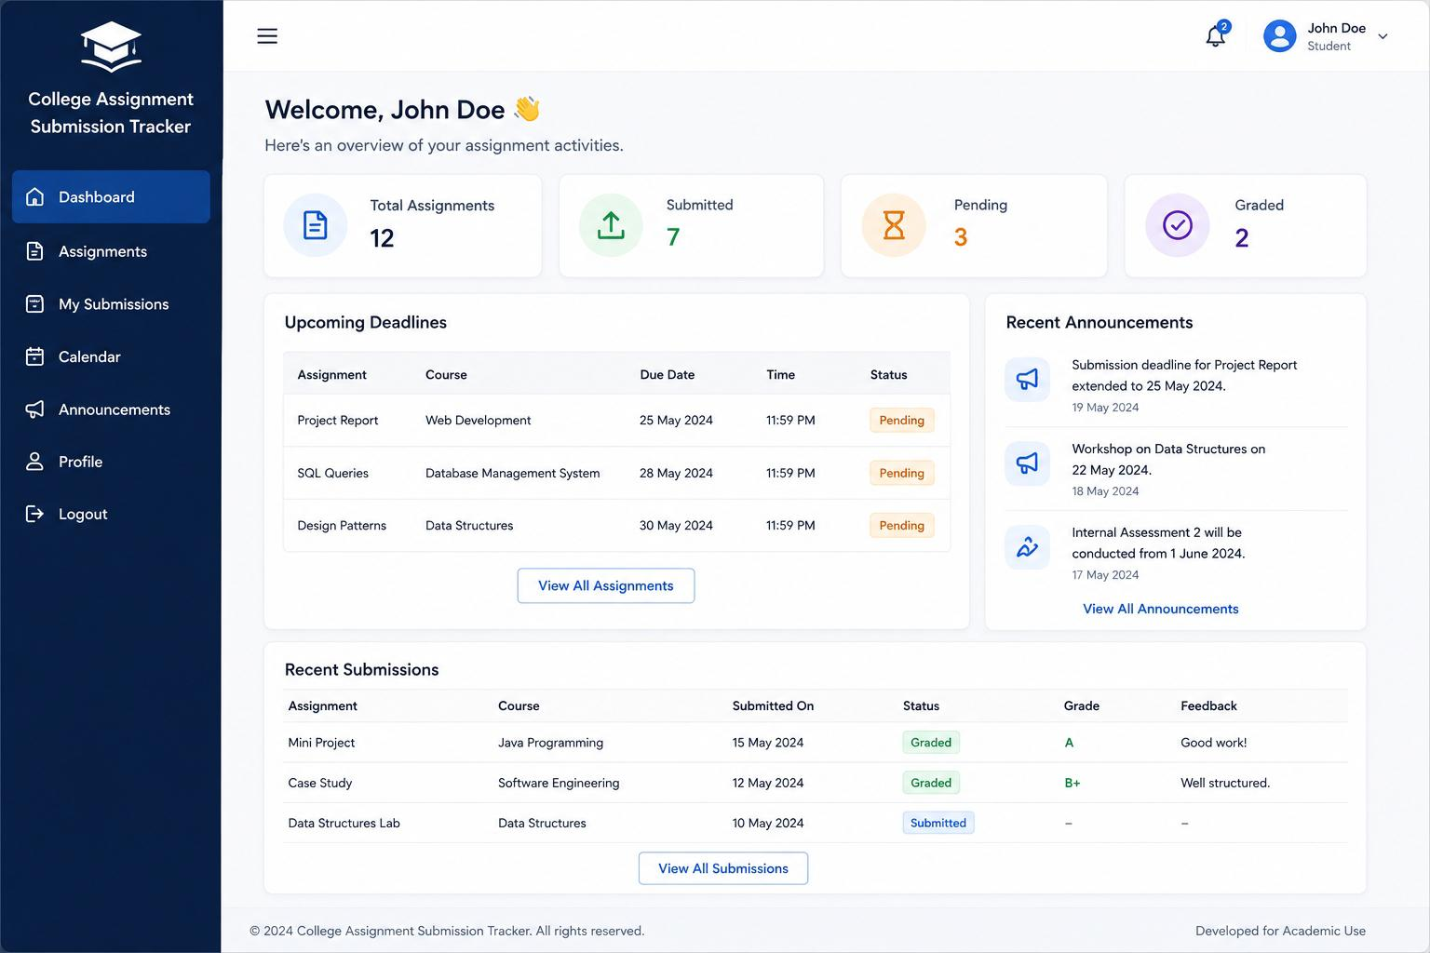
8. EXPECTED OUTPUT

• The application successfully renders a clean single-page dashboard. The user can add inputs via the form, view instant changes in the assignment list, change individual status properties, and see the top dashboard summary cards update their numbers automatically without any page reload.

9. CHALLENGES FACED
• Challenge: Managing state logic to dynamically recount the dashboard totals whenever an assignment’s status was changed or a new one was added.

- Resolution: Solved by utilizing a centralized state in the parent App.js component and creating a function that automatically calculates status lengths upon every state re-render.

10. LEARNING OUTCOMES
• Gained hands-on experience in building a project from scratch using React.js.

- Mastered state management, prop passing, and form handling in React.

- Developed a better understanding of component hierarchy and writing clean, scalable JavaScript/CSS code.

11. CONCLUSION
The College Assignment Submission Tracker project successfully meets all its predefined objectives. It solves the real-world issue of unorganized academic tracking by replacing manual logs with an interactive, instant-loading frontend dashboard. This project highlights the power of React in creating robust, efficient Single Page Applications.

